The Glass "Alternative" for
Prefllled Pharmaceuticals

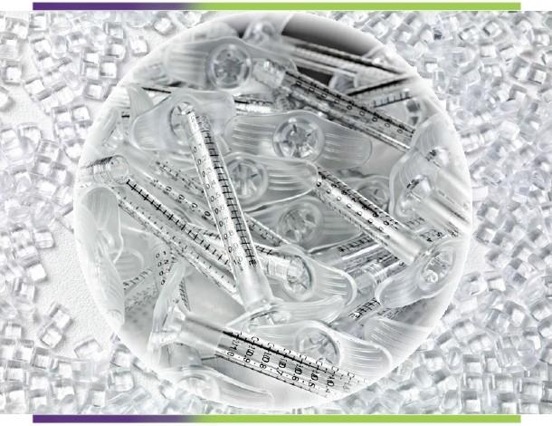

www.plastechengineering.com

Benefits Over Glass
Cost: 1/4 to 1/10 the cost of glass syringe luer lock syringe assemblies Shatter Resistance: Will not shut down pharma filling production line Weight: <50% that of glass thus reducing shipping costs
Design Flexibility: Finger grips, luer tip style, back stop - molded in features
Very Low Protein Absorption

Benefits over PC and PP
BPA Free
Higher Moisture and Gas Barrier for Greater Shelf Life
Better Optical Properties and High Transparency
Better Chemical Resistance and Biocompatibility Characteristics
Sterilizable: Steam, Gamma, ETO, E-Beam Very Pure with Near Zero Out Gassing Very Low Protein Absorption

Material Options
Cyclo Olefin Polymer (COP), manufatured by Zeon Chemical L.P (Zeonex®) Cyclic Olefin Copolymer (COC), manufactured by Topas Advanced Polymers

Water Absorption
< 0.01%
Benefit: Shelf Life

Air Permeability
Depends on Wall Thickness
Benefit: Shelf Life better than PP or PC, but less than glass

Chemical Resistance
Very good when compared to glass
Superior to PC and PP

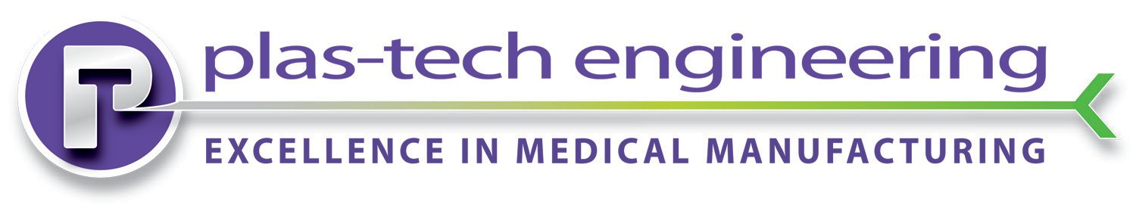875 Geneva Pkwy N., Lake Geneva, Wisconsin 53147 Tel. 262-248-2379
ISO 9001:2008
FM 545128
FDA/GMP Compliant

www.plastechengineering.com
Fax. 262-248-2289
ISO 13485:2003

